Warning – Fuel Maintenance – PHEV

Functional Description

The PHEV system shall provide feedback to the customer regarding the status of the fuel maintenance mode.

The IPC shall display a warning message to let the customer know that the engine needs to run to maintain fuel freshness.

The Fuel maintenance (Fuel Freshness pop-up message) is based on the fuel maintenance status signal from the HPCM (FuelMaintMde_D_Dsply)

Interfaces

Interface Context Diagram (I/O Block Diagram)

- Warning – Fuel Maintenance Warning Function Context Diagram
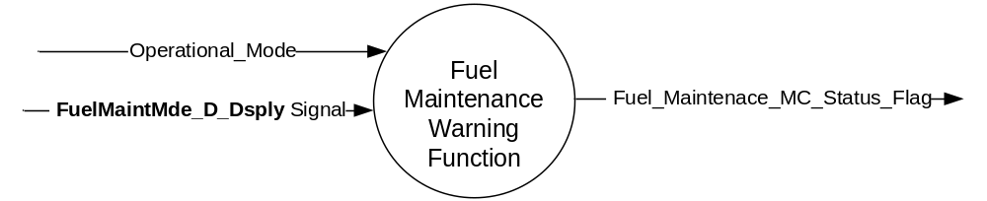

Inputs

- INTERNAL:

- Operational_Mode

- MUX signal

- FuelMaintMde_D_Dsply Signal

Signal Name | Size (bits) | Detail | Units | Res. | Offset | State Encoded | Min | Max
FuelMaintMde_D_Dsply | 2 |  | SED | 1 | 0 |  | 0 (0x0) | 3 (0x3)
 |  | OK |  |  |  | 0x0
 |  | Close_to_Fuel_Maint |  |  |  | 0x1
 |  | In_Fuel_Maint |  |  |  | 0x2
 |  | Feature_Not_Present |  |  |  | 0x3

Outputs
- INTERNAL:

- Fuel_Maintenence_MC_Status_Flag

Function/Performance

Operational Modes

Mode | Differentiating Vehicle Conditions
Sleep Mode | Fuel Maintenance Warning Disabled
Limited Mode | Fuel Maintenance Warning Disabled
Normal Mode | Fuel Maintenance Warning Enabled / Disabled
Crank Mode | Fuel Maintenance Warning Enabled / Disabled

Voltage Levels

Refer to the Cluster Features table located in the Operational Modes and Voltage Range Strategies Section in this SPSS.

Human-Machine Interface

Visual

Indicator Graphics / Display Format
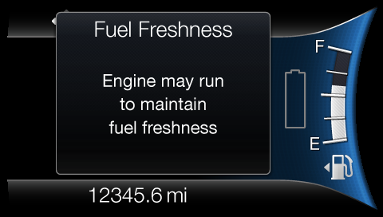

W701

For actual display, refer to the latest HMI graphics

Indicator Color Coordinates

Reference section COLOR & ILLUMINATION REQUIREMENTS (GRAPHICS)

Indicator Characteristics

Refer to Message Center X Display_Y Button Interface Section, where X and Y are appropriate values in this document.

Audio

None

Switch Control Logic

N/A

System Accuracy

Within a 100msec of receiving a message that results in a change of state the cluster will update the display to the proper status.

Operation: Performance and Functional

Subsystem Algorithm Flowchart / State Diagram

- Fuel Maintenance Warning Flag State Matrix

Operational_Mode | FuelMaintMde_D_Dsply signal | Fuel_Maintenance_MC_Status_Flag
Normal or Crank | 0x2  (In_Fuel_Maint) | Active (0x1)
All Other Cases |  | Inactive (0x0)

Operation Description (supports algorithm flowchart /state diagram)

- Fuel Maintenance Warning Flag to MC Warning Message ID

Warning Flag | Warning #
Fuel_Maintenance_MC_Status_Flag | W701

- For definition of how the Message Center arbitrates and displays Active warnings, see the Warning / Alert Display Logic Diagram, located in the Message Center – X Display with W Button Interface section of this SPSS (where X and W are appropriate values in this document).

Function Safety Classification (EMC)

Class B

Memory Storage

Parameter Name | Description | Value at  Battery Connect | Value at  Module Wake-up
FuelMaintMde_D_Dsply signal | CAN signal, transmitted by the HPCM to indicate being in fuel maintenance mode. | 0x0 | 0x0
Fuel_Maintenance_MC_Status_Flag | Internal status flag to indicate whether or not the Oil Maintenance warning should be displayed | Inactive (0x0) | Inactive (0x0)
Operational_Mode | 4 state indicator for cluster operational mode | Limited | Limited, Normal or Crank

Prove Out

Not applicable

Reconfigurable Telltale

Not Applicable

Message Center Msg

Warning Message ID W701 as defined in the Text Message List section of this SPSS.

Error Handling

Missing Message Strategy

None

Diagnostics

Self Test

None

Engineering Test Mode

Reference section “Dealer / Engineering Test Mode (ETM)”

Part II Performance

Supported Diagnostic Trouble Codes (DTCs)

DTC | Description
None

Reference Specification

  - CAN Database
  - DIDC
  - Message Center Warnings
  - HMI graphics

Revision History
SPSS Module Revision History

Revision Level | Name | Change Description | Date
1.0 | S. Watkins | Initial Release. Updated from legacy non-CGEA version 1.0. | 09/20/2016

